MATCHDAY INFORMATION

Welcome to the match day information page which we hope will provide you with most of the information that you will need to enjoy your visit to our ground - the Red Industries Stadium.

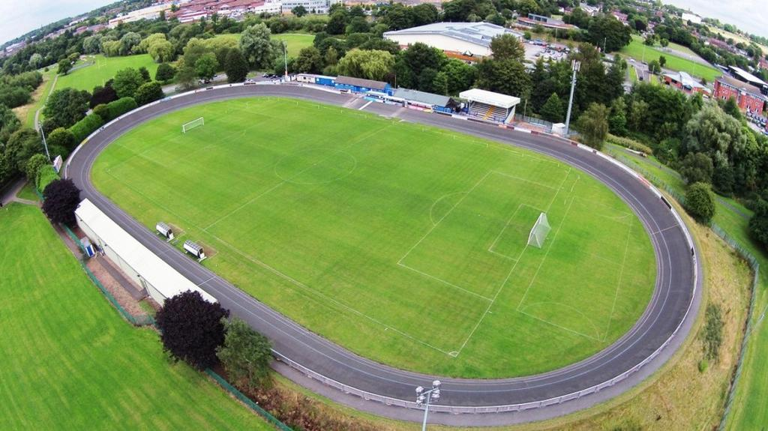

Admission Prices 2021-22

Adults - £9.00
Concessions - £6.00
Children Under 16 - Free

Youth Team

Adults - Free
Concessions/Children – Free

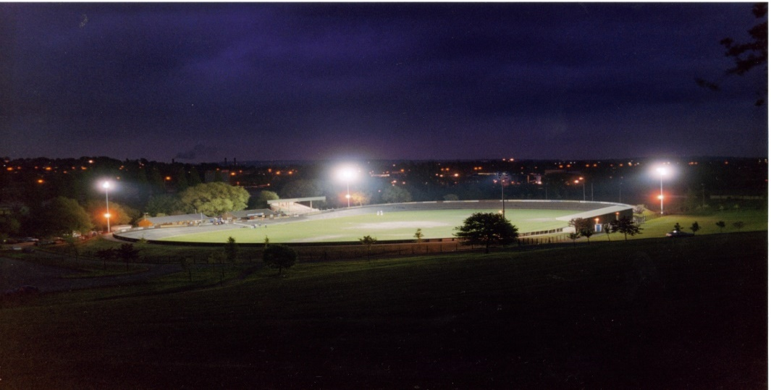
SOCIAL CLUB
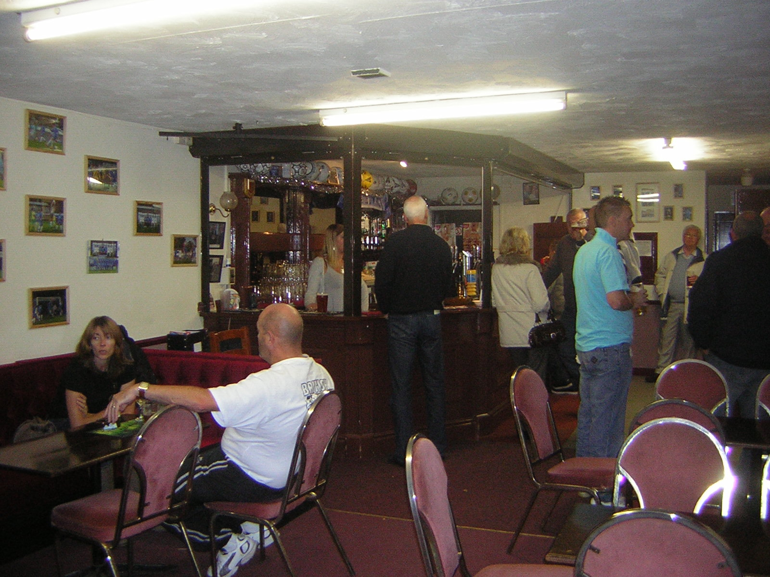

Our Clubhouse will be open from 12pm midday for every home game. We serve a range of draft and bottled beers, spirits and soft drinks. The clubhouse has Sky Sports and will be showing the live games of the day from 12pm onwards.
Food will be available from 1pm from our Snack Bar.
The club can be hired for social functions. For details of how to hire the club please phone Geoff Eccleston on 07939952793 or Gavin Appleby 07904511561

MATCHDAY PROGRAMMES

Matchday programmes are available to buy just inside the turnstiles or at times on the turnstiles themselves. The cost of a programme is £1-00 (First Team). Programmes from previous games can be bought from the club shop.

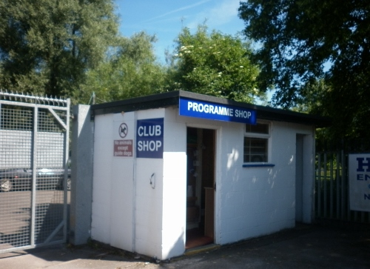

The Programme Shop is situated just inside the main gate and is open on matchdays. You can by Newcastle Town souvenirs and programmes from past matches as well as programmes and souvenirs from other non-league and league clubs.

FUNDRAISING

Why not have a go on our Golden Eight Teams Draw(£1). Also listen out for other fundraising events on the day. There are plenty of opportunities for sponsorship so why not have a word with Geoff.

THE SNACK/TEA BAR

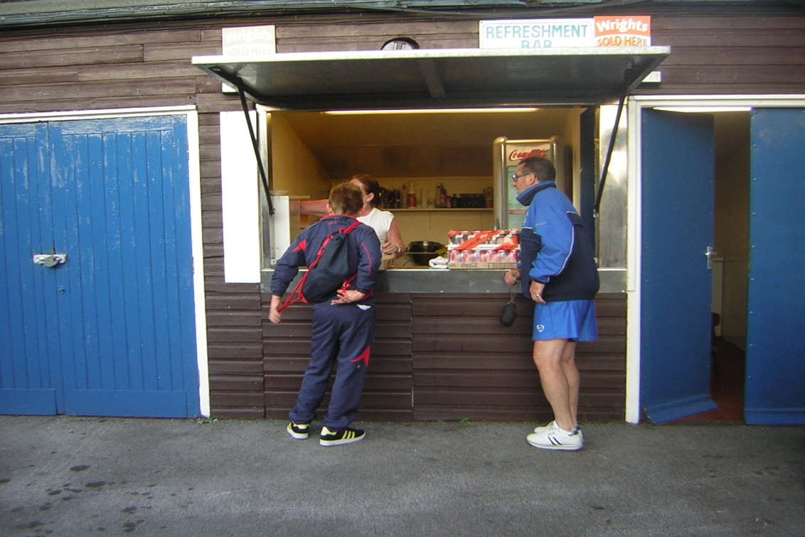

The Snack Bar is open on matchdays from 1.00 pm on Saturdays and 6.30 pm for evening games.. You can buy hot and cold snacks, pies (Wrights), sausage and chips etc and hot and cold drinks - all at reasonable prices. It is situated next to the Clubhouse.

CAR PARKING

There is a car park adjacent to the ground with enough space for 150 cars.

TOILETS

Male and Female Toilets can be found adjacent to the changing rooms and also in the Clubhouse. There is also a Disabled Toilet adjacent to the changing rooms.

For any other information please contact us using the web page How To Contact Us or telephone 01782 662350.

