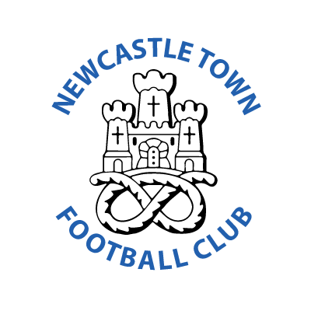

NEWCASTLE TOWN FOOTBALL CLUB LTD
LIMITED BY SHARES – COMPANY NUMBER : 02265186
Significant Shareholders : Paul Ratcliffe 40% Jeffrey Harrall 36%

HEADQUARTERS : The Red Industries Stadium, Buckmaster Ave, Clayton. Newcastle-Under-Lyme, Staffs. ST5 3BX Tel : 01782 662350

E-mail : secretary@newcastletownfc.co.uk
POSTAL ADDRESS : Newcastle Town Football Club Ltd, Roe Lane Playing Fields, Roe Lane, Newcastle-Under-Lyme, Staffs. ST5 3PH

President : James T Blakeman
Chairman : Paul Ratcliffe
Vice Chairman : Gavin Appleby
Financial Director : Jeffrey Harrall
Youth Section Chairman : Gavin Appleby

Board of Directors : Paul Ratcliffe, Gavin Appleby, Jeffrey Harrall, Robin Van Der Laan, Terry Donlon, Michael Pagett.

Committee Members : Ray Tatton, Geoff Eccleston, Len Matthews

Club Secretary : Ray Tatton – Tel : 07792 292849
Matchday Secretary : same as above + Geoff Eccleston - Tel 07939 952793

Groundsman : Dave Rhodes
Assistant Groundsman : Derek Hartley
Clubhouse Manager : Stephen Christie
Kit Manager : Joanne Hopwood/Jones
Media Officer : Shaun Rogers

Club Doctor : Mr Dos Remedios
Physio : John Davies
First Aiders : Mark Williams, Brian Bennett, Gavin Appleby.

Welfare Officer : Kerry Appleby - Tel : 07839 187642
Safety Officer : Simon Billings – Tel : 07968 714795

Golden 8 Promoter : Geoff Eccleston - Tel 07939 952793
Inclusion Officer in Partnership with Regent College : Julia Bossons

MEMBERS OF THE PITCHING IN NPL and THE STAFFS FA

